Tables:

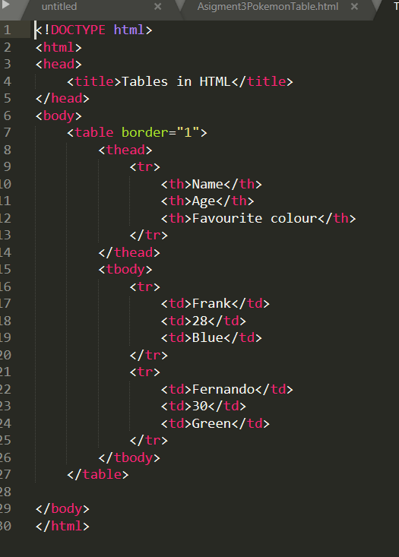

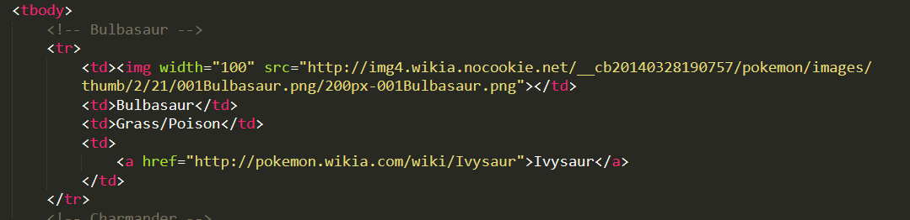

Introduction to forms:

<form>: container where all my data is actually saved

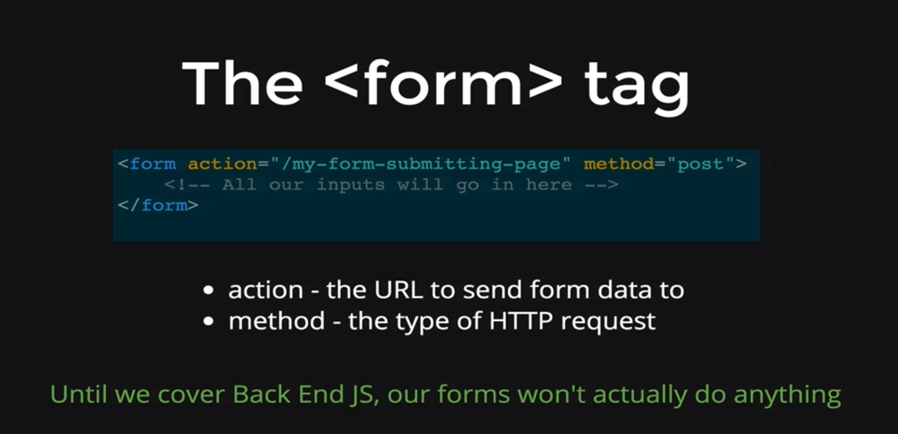

Example:

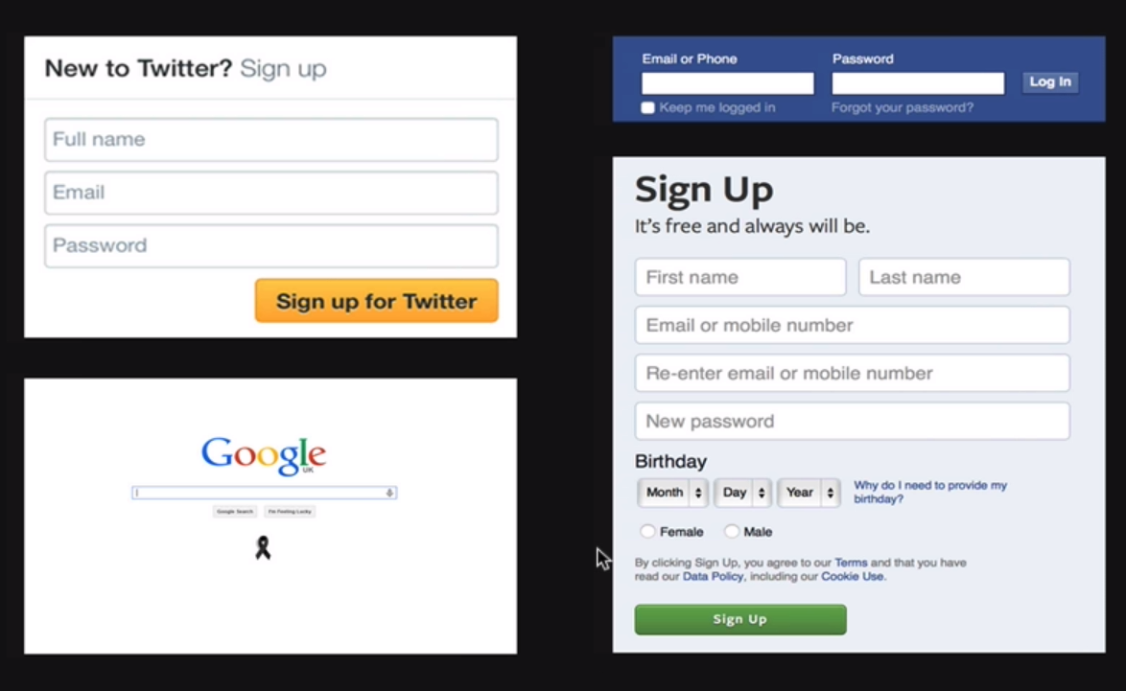

* There will be 2 types of method:
  + Get request: get data from the server
  + Post request: adds data to the twitter/facebook/google database

Input Tag

Creates container to input data

Link: <https://developer.mozilla.org/en-US/docs/Web/HTML/Element/input>

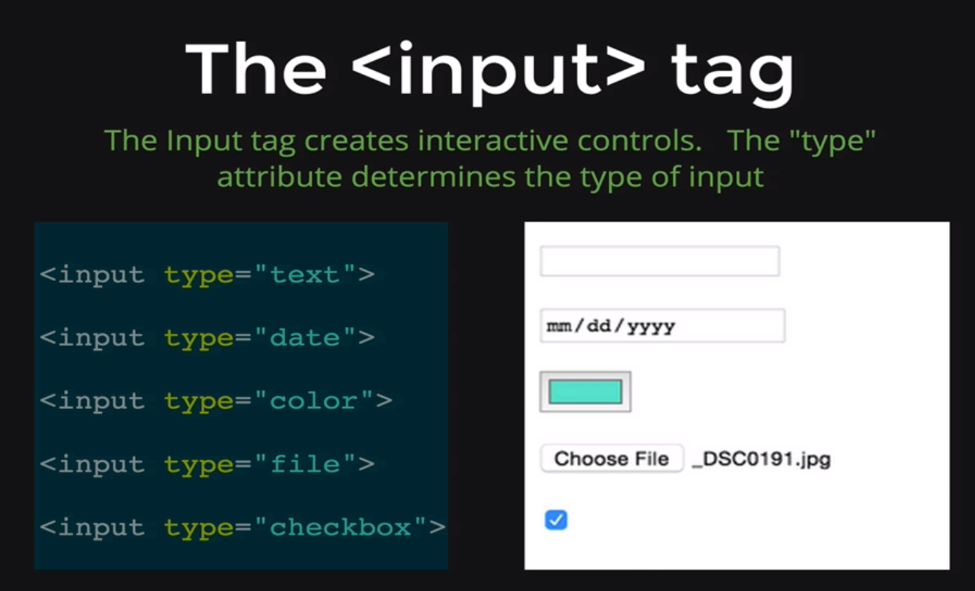

Example:

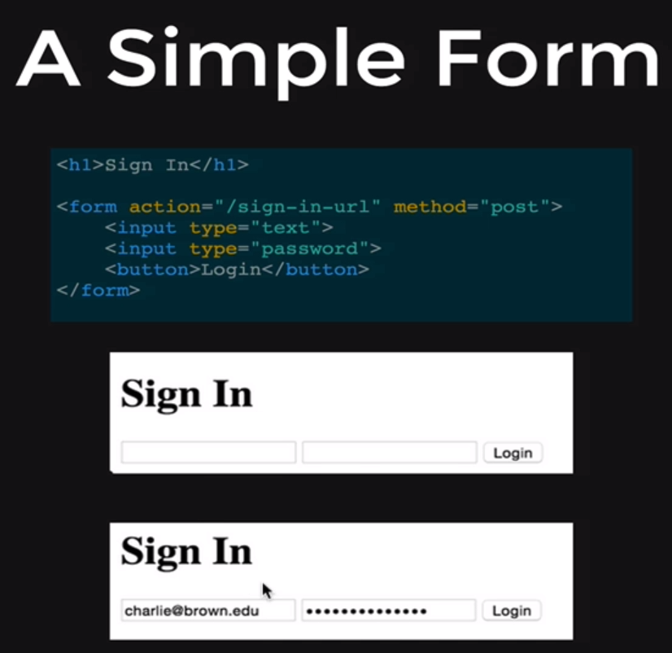

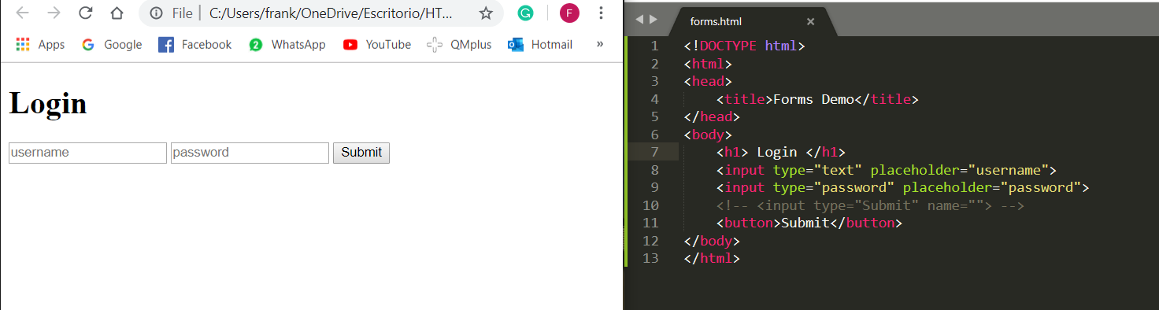

Sending Request

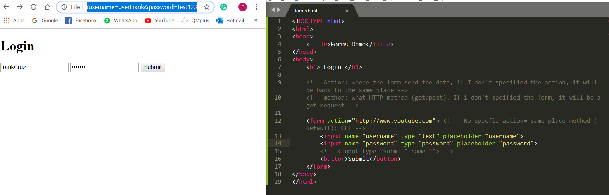

Labels

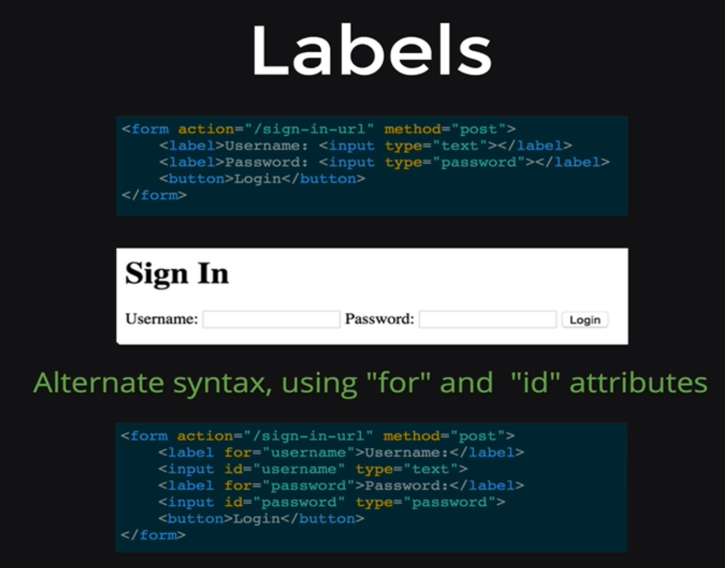

Example:

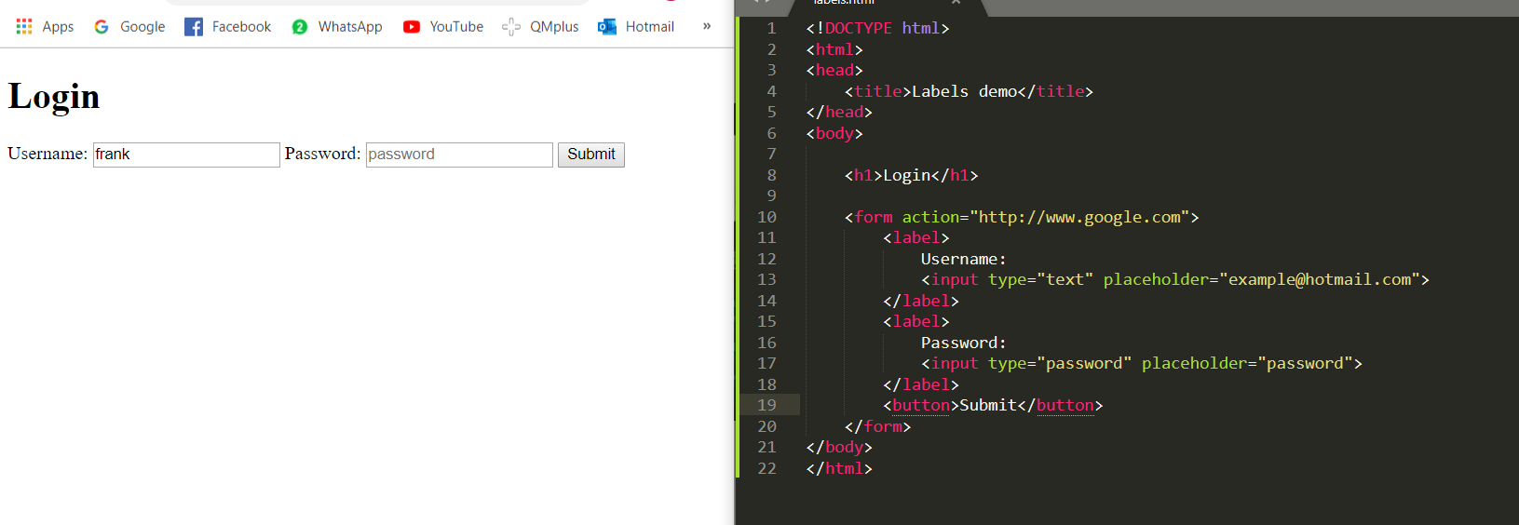

Matching: “for” and “id” : these two have to have the same name value

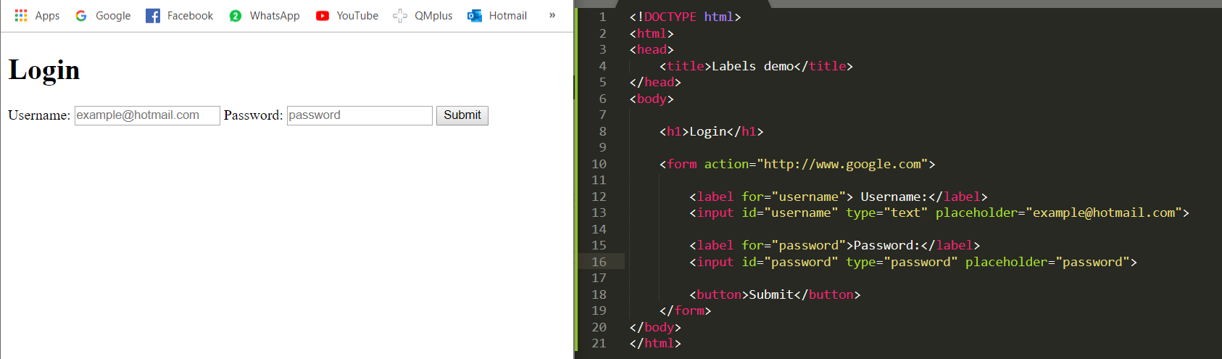

Form Validation: (Adding required in the input box)

* Input does not have to empty

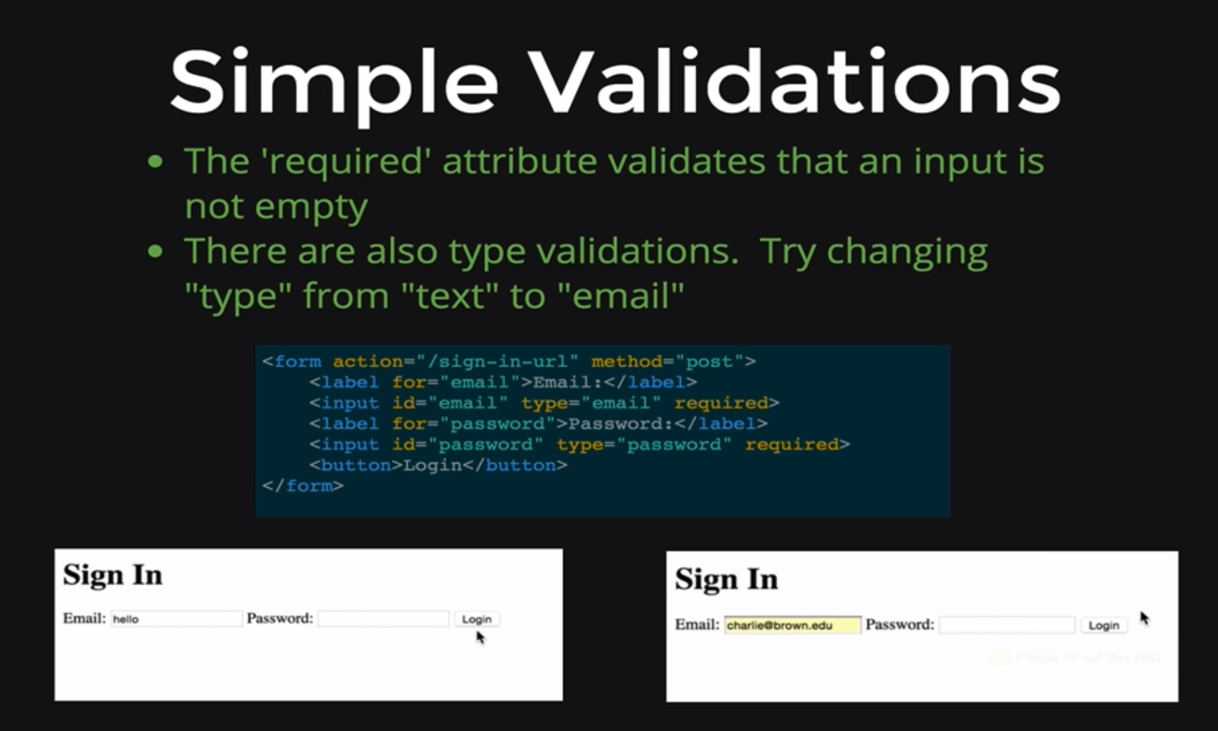

Example: 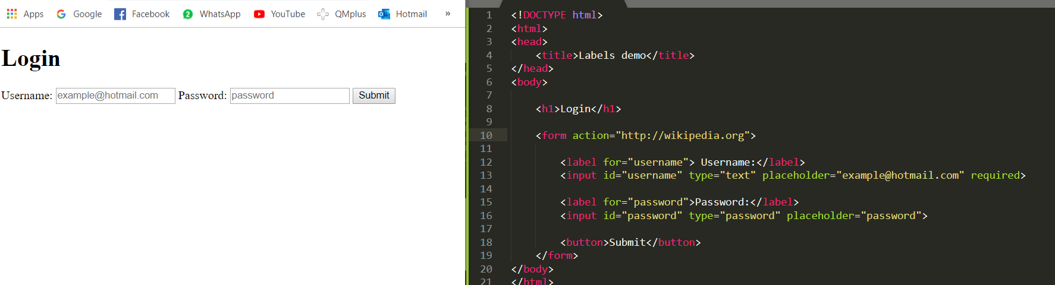

* Type of data input: by changing the “type:”” ” to email or something else

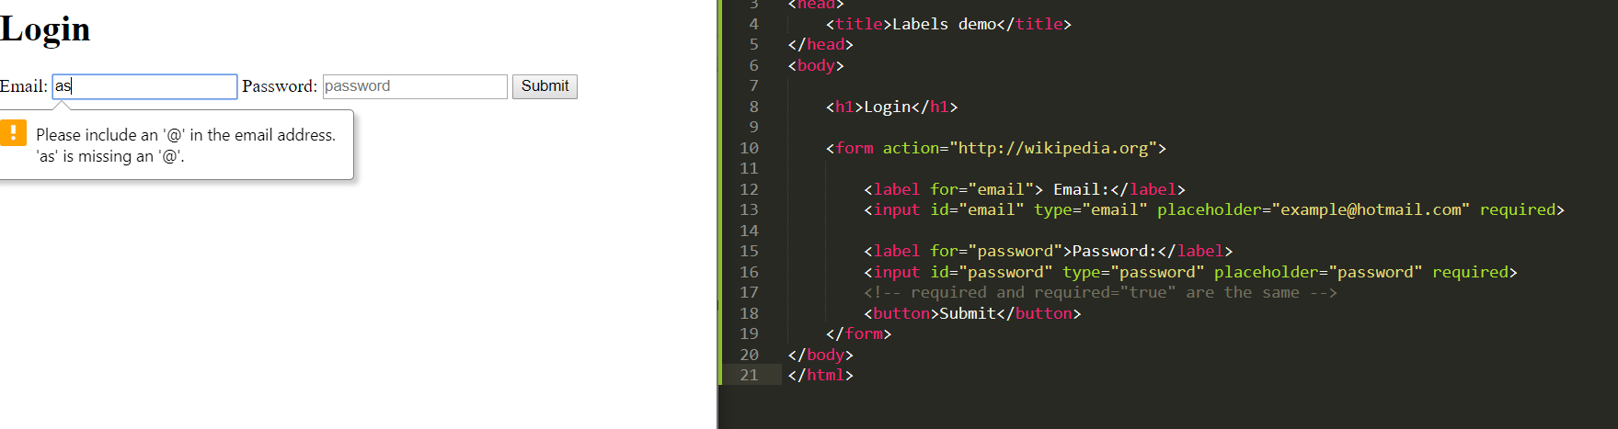

**USING NAME and VALUE**

Radio Tag

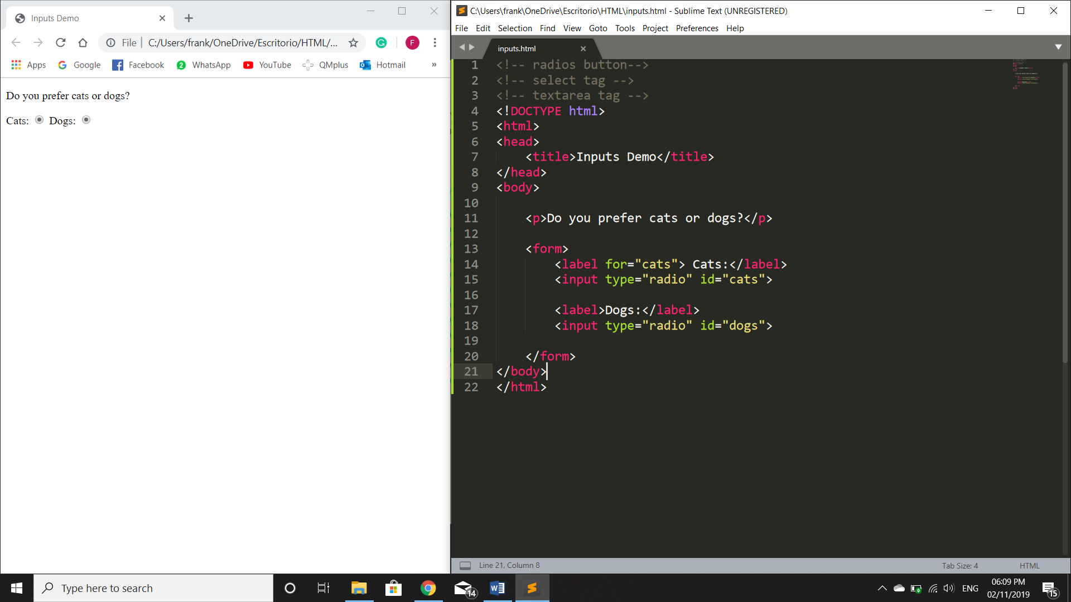

* Having the same “name”, we can either only click on one single choice

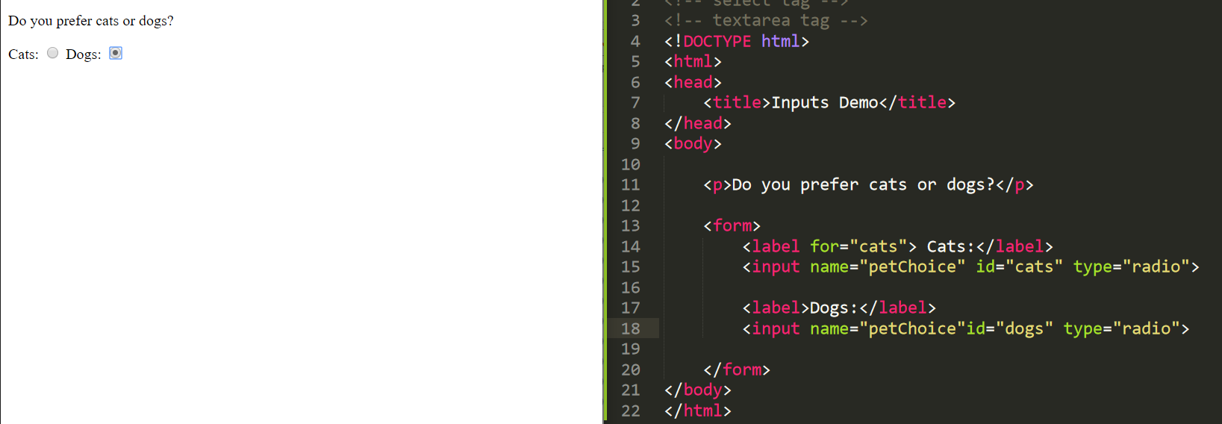

As It can be seen, “name”: petChoice value is filled up with “on” result

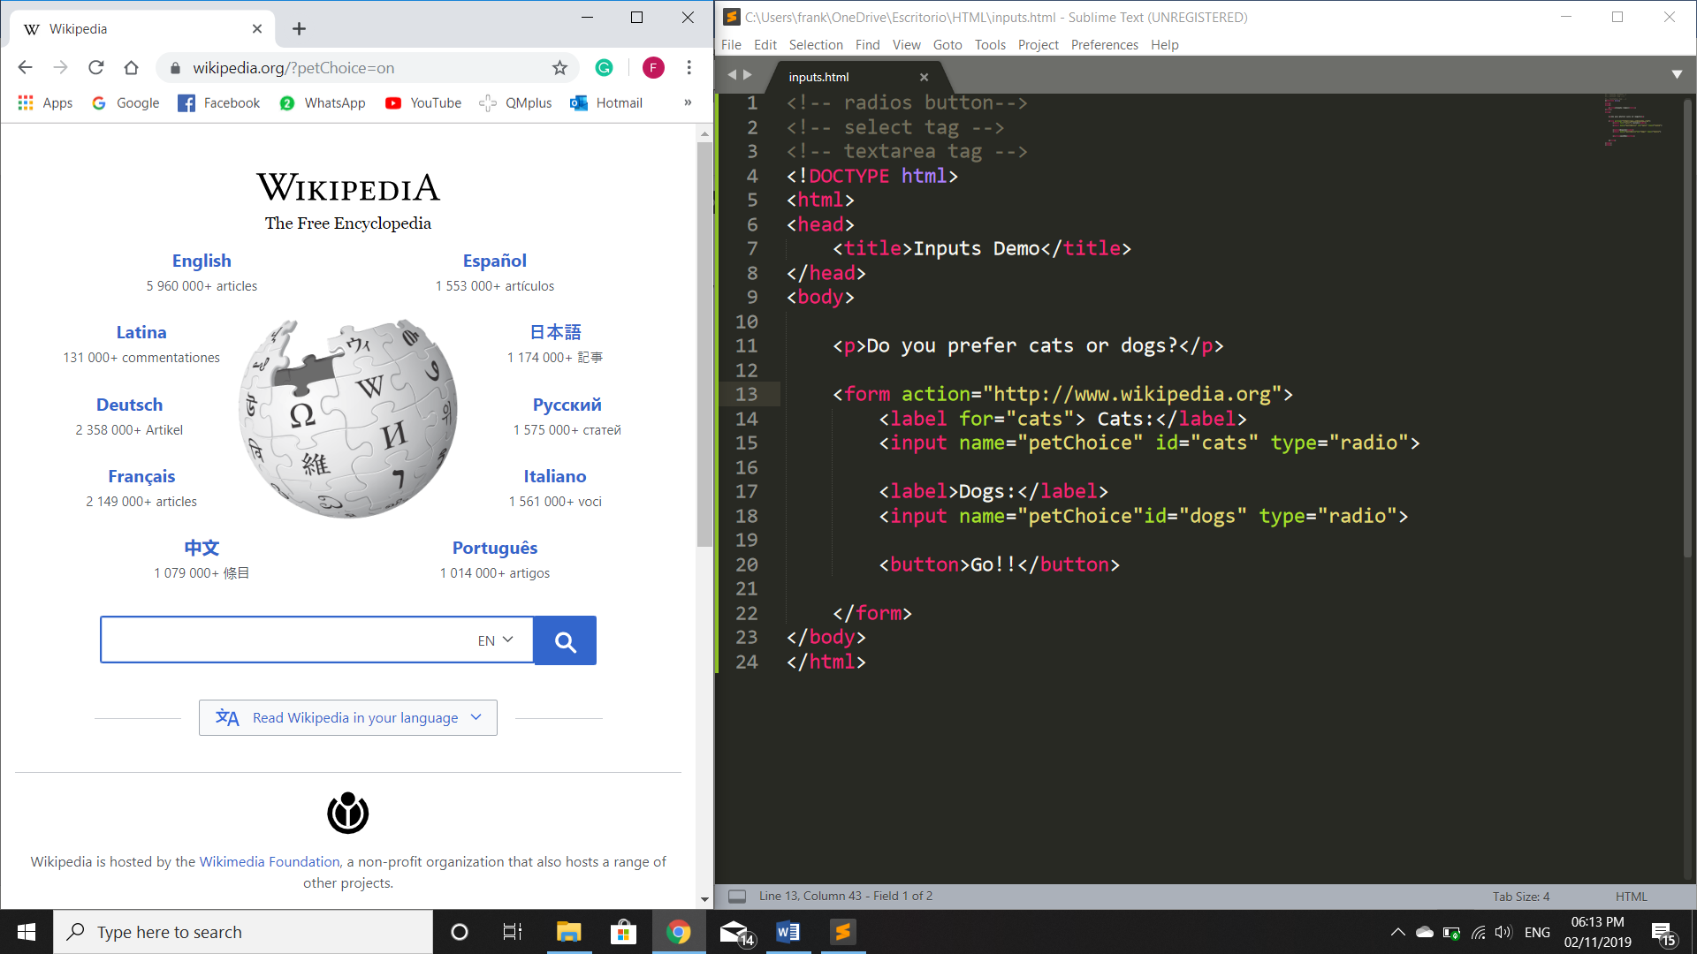

* Adding the “value” = “something”type, it will return now, pertChoice=(value)

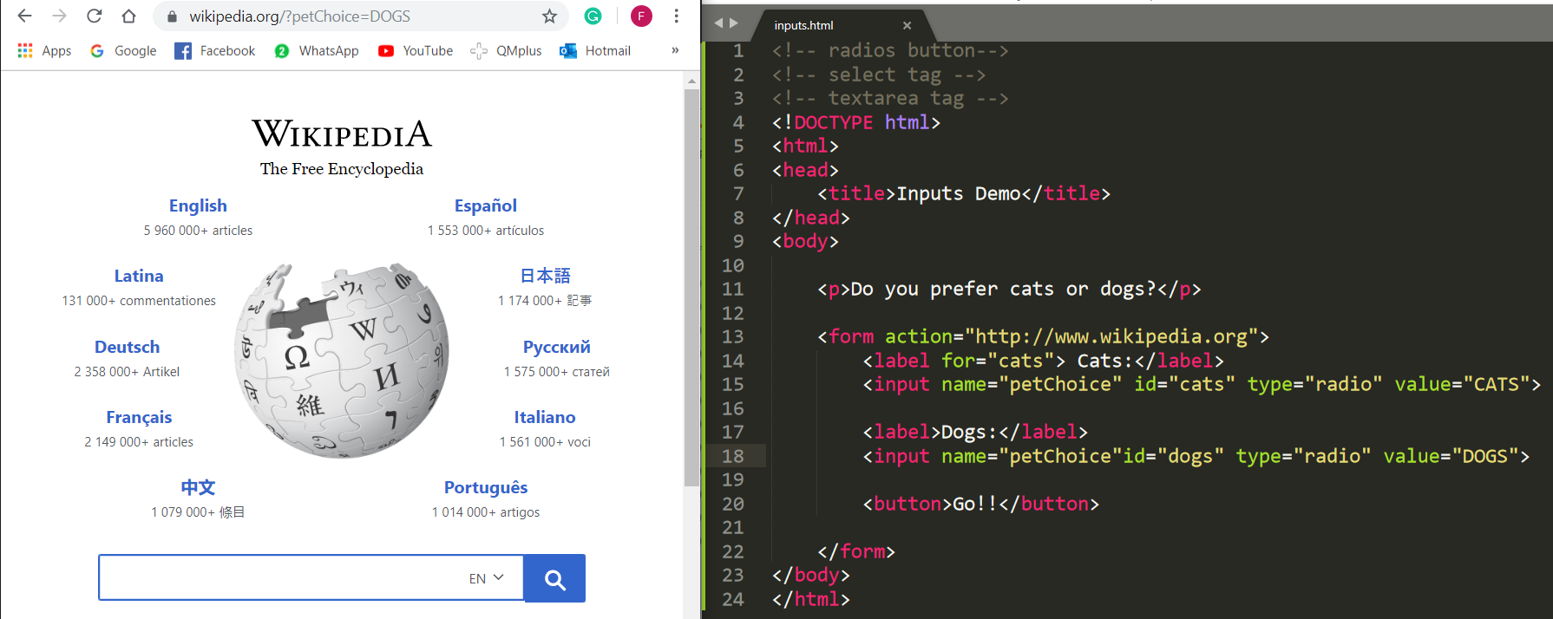

Select Drop down menu

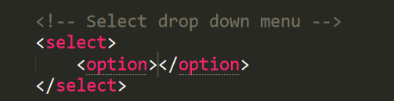

We can see that the name and value are filled with its respective “value”

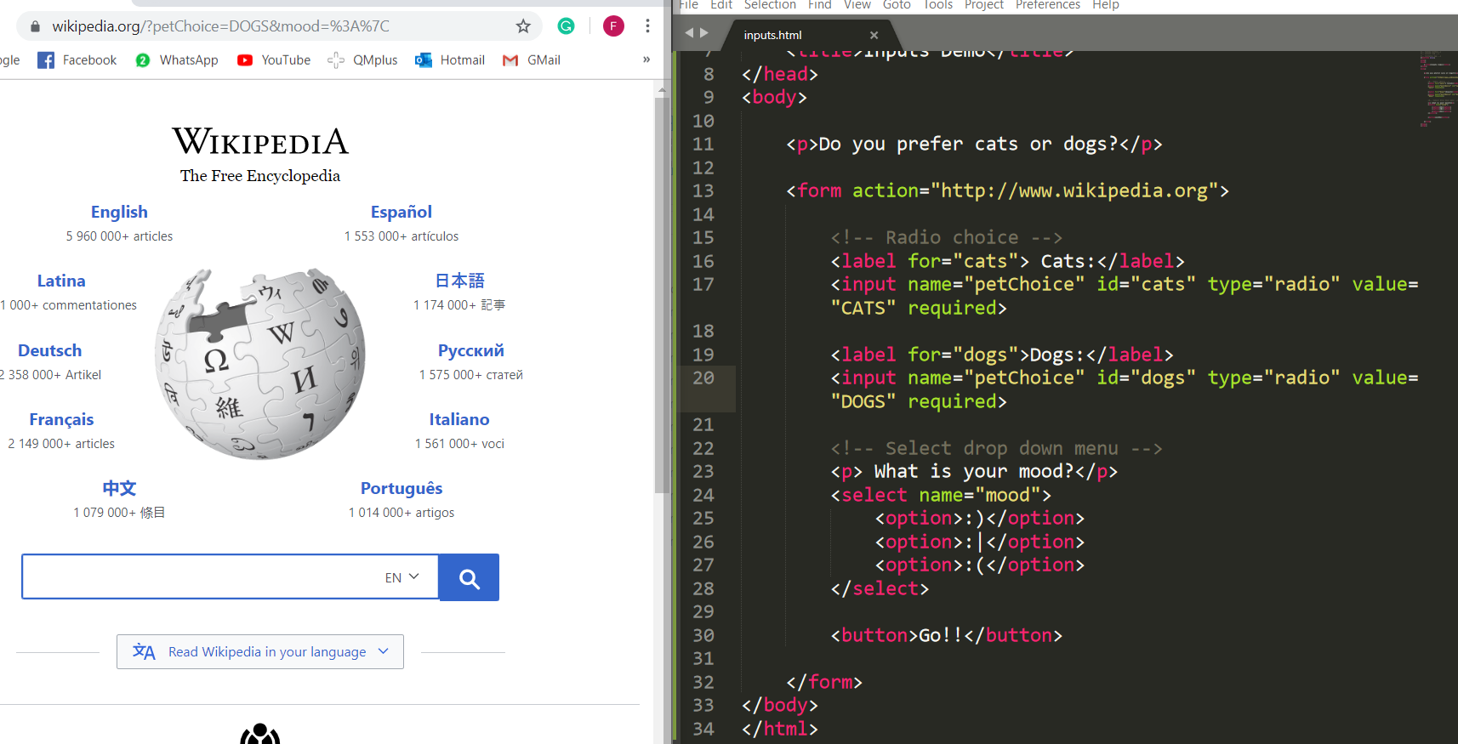

**But we don’t want to send those characters, otherwise, their respective value

